Jupyter Assignments as HTML

Go to the top bar of your Jupyter notebook:

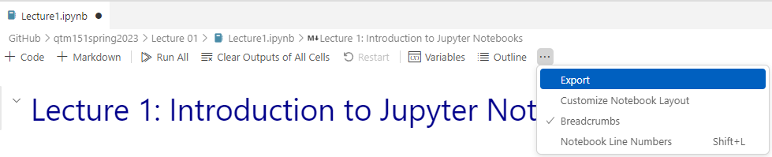
Select the option “HTML” and store it in the same folder as the assignment.

ONLY upload the HTML file
- This make it easier for us to grade your assignment because we can see your output directly in the browser.

